R State Scale Survey Report Tool Supplement

This document demonstrates how to dynamically create those fields and insert them into your document.

## Create Spatial Layers - Sampling points

This code creates a shapefile from a table of lat/longs and associated attributes. You could also import your own shapefiles created in GIS instead.

With spatial layers, when you are noting sample sizes other than Nrep, now you could dynamically reference the spatial layer instead of the sample database or table. VA created several spatial layers (such as ones corresponding to each IR year iteration), so it was simpler to reference the number of samples in each IR based on the spatial data layer rather than referencing the original dataset using multiple layers of filters. How you reference sample numbers is entirely based on your data preferences and structure.

Examples of dynamic referencing: There were 50 samples collected in 2009 and 30 collected in 2010. There were 300 samples collected in the North and South Basins from 2009-2018. For the 2018 IR (from 2011 - 2016), there were 420 samples collected. Or, there were 150 samples collected in the West and East Basins from 2011 - 2016.

With all of those layers created, it is easy to display different combinations of them on a map.

##### Figure 1.2. Probabilistic monitoring locations from 2011 - 2016 (n = 420).

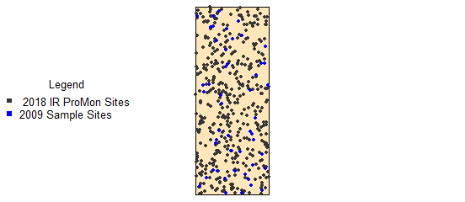

##### Figure 1.3. Probabilistic monitoring wadeable locations from 2013 - 2018 (n = 750).

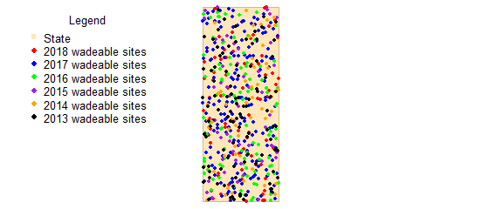

## CDF Table Lookup function

This function looks up one parameter/indicator value (usually defined to correspond with a threshold for a category) and confidence bounds from a cdf table for every basin that is programmed into the function.

This functions will only work for indicators that have basin data for basins included in the function. In the example data, that is only the MMI indicator. The rest of the indicators do not have basin data subsets.

If you calculated stressors extent and relative risk, these are some examples ways you could display the results. The first figure displays the the estimated percent of rivers not meeting standards or thresholds (impaired).

##### Figure 2.4-23. Stressor extent for major benthic macroinvertebrate stressors in Middle Earth streams. The horizontal lines associated with the parameters illustrate the confidence intervals. Stressor extent shows the frequency of the stressor in all Middle Earth streams from data collected for the 2018 Integrated Report (2011 - 2016).

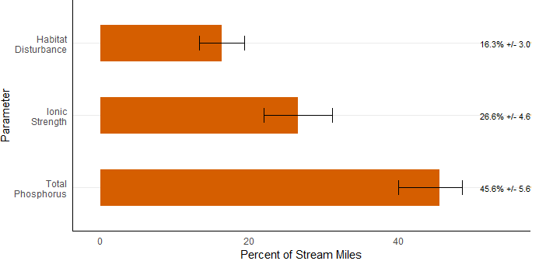

The next figure displays relative risk results. For more on calculating relative risk see [Relative Risk and Attributable Risk Analysis](https://cran.r-project.org/web/packages/spsurvey/vignettes/Risk_Analysis.pdf) or the [spsurvey Package documentation](https://cran.r-project.org/web/packages/spsurvey/spsurvey.pdf).

##### Figure 2.4-24. Relative Risk for major benthic macroinvertebrate stressors in all Middle Earth streams. The horizontal lines associated with the parameters illustrate the confidence intervals. The vertical dashed line at 1 indicates significance; thus, all relative risk estimates and confidence intervals that exceed the dashed vertical are significant. Relative risk shows the number of times more likely a benthic macroinvertebrate community is to be scored in the suboptimal range if the parameter shown on the y-axis is degraded. Data encompasses samples collected from 2009 - 2016.

